**Commodore VIC-20: Hyper Expander Rev. 2**

**Testing**

# Test Setup

The tests were conducted with a VickyTwenty (a reproduction of the VIC-20 ASSY 250403) and two Hyper Expander cartridges Rev. 2. One was a RAM and 1 EPROM configuration with two HN61256BLP-7 RAM and up to two 27C512 EPROMs, the other was a 16k EPROM cartridge with two HN61256BLP-7 RAM.

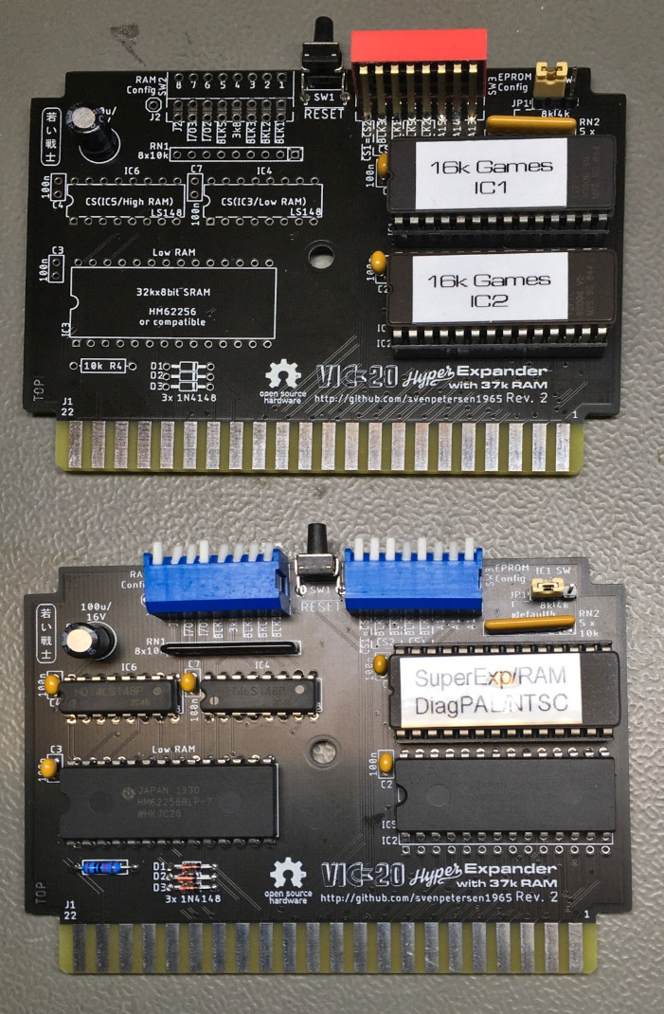

Figure 1: Prototypes of Hyper Expander Rev. 2: 16kB EPROM (top), Full RAM and 8k EPROM (bottom)

# Test Execution

## Super Expander Software

First, the original Super Expander Software from zimmers.net and the VIC-MON for $B000 were programed to an EPROM. These two programs fit into one 8k memory bank, since the Super Expander software is a 4k software. The EPROM was inserted the in IC1 socket and was set to ($A000-$BFFF). The RAM was configured to 3k RAM expansion only (SW2: all off, except switch 4 on ).

|  |  |  |  |  |  |  |  |
| --- | --- | --- | --- | --- | --- | --- | --- |
| SW3-8  CS1=CS2 | SW3-7  BLK3 | SW3-6  BLK1 | SW3-5  BLK5 | SW3-4  BLK2 | SW3-3 A15 | SW3-2  A14 | SW3-1  A13 |
| off | off | off | on | off | on | on | on |

The cartridge was inserted into the VIC-20 and the computer was switched on. It booted normally and 6519 Bytes Free were reported. The Super Expander requires bytes in RAM, so this is correct.

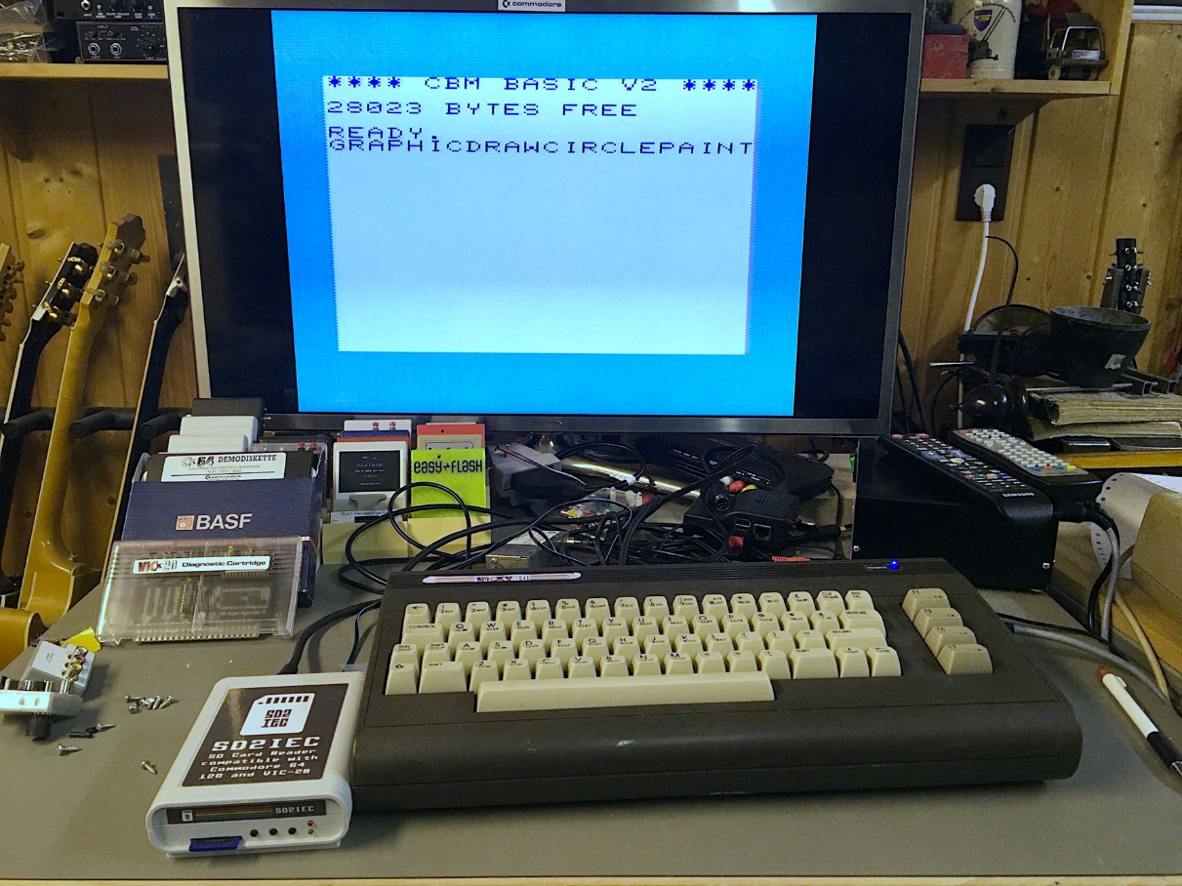

Figure 2: Test with Super Expander Firmware and full RAM expansion

The function keys produce some of the additional Super Expander instructions. A short program, which is using those instructions, was executed successfully.

* **Function of RAM and EPROM IC1 with and the Super Expander Software verified.**

SYS11*4096 (which is $B000) started the VIC-MON.

* **Additional test.**

The Super Expander Software was tested with all other RAM configurations, the VIC-20 always booted properly.

## RESET Button

The RESET button (SW1) was pressed. The VIC-20 rebooted properly.

* **RESET button verified**

## VIC-20 Diagnostic Software

The software (PAL) also origins from zimmers.net. It was programmed into the 2nd 8k bank of the said EPROM, a different version of this software (NTSC) was programmed to the 3rd 8k bank.

The EPROM banks were set to the 2nd 8k SW3 switch 5 remained on ().

|  |  |  |  |  |  |  |  |
| --- | --- | --- | --- | --- | --- | --- | --- |
| SW3-8  CS1=CS2 | SW3-7  BLK3 | SW3-6  BLK1 | SW3-5  BLK5 | SW3-4  BLK2 | SW3-3 A15 | SW3-2  A14 | SW3-1  A13 |
| off | off | off | on | off | on | on | off |

The RAM was configured to 3k Expansion only.

The diagnostics software started and executed properly (together with the VIC-20 diagnostics harness). For the 2nd version of the diagnostic software, SW3 was set to the 3rd 8k bank

|  |  |  |  |  |  |  |  |
| --- | --- | --- | --- | --- | --- | --- | --- |
| SW3-8  CS1=CS2 | SW3-7  BLK3 | SW3-6  BLK1 | SW3-5  BLK5 | SW3-4  BLK2 | SW3-3 A15 | SW3-2  A14 | SW3-1  A13 |
| off | off | off | on | off | on | off | on |

This software executed properly, too.

* **Bank select (000, 001, 010) on SW3 verified**

## Game Cartridge Donkey Kong

This game is a 16k game and requires both EPROMs.  
The software for $A000 was programmed in a fresh EPROM, which was inserted into IC1. SW3 remained at . The other part of the software, which is located at $2000 was programmed into another fresh EPROM, which was then inserted into the IC2 socket.

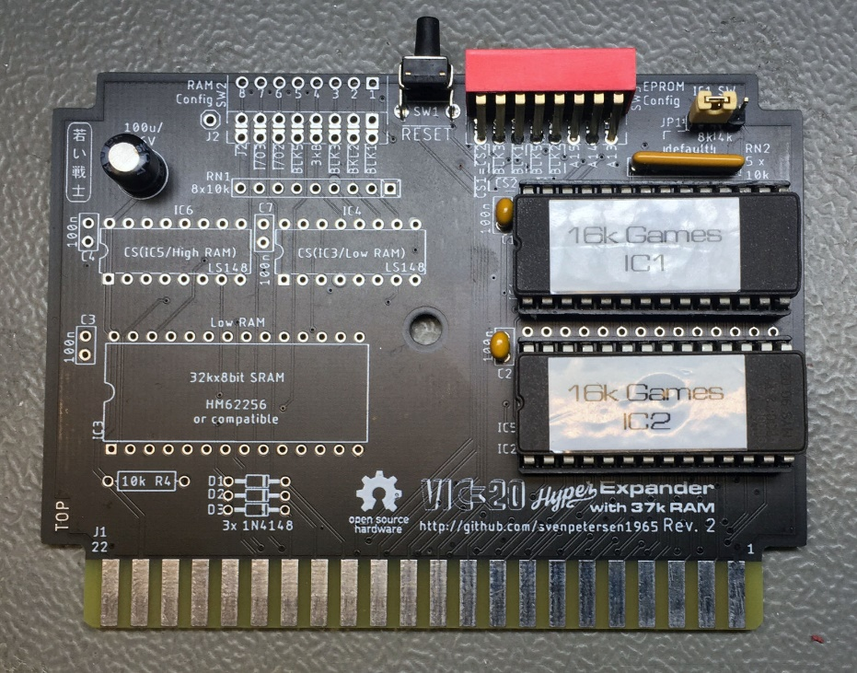

Figure 3: Configuration withn two EPROMs

SW3 was set to (SW3-1..8: on, on, on,off, on, on, off, off).

|  |  |  |  |  |  |  |  |
| --- | --- | --- | --- | --- | --- | --- | --- |
| SW3-8  CS1=CS2 | SW3-7  BLK3 | SW3-6  BLK1 | SW3-5  BLK5 | SW3-4  BLK2 | SW3-3 A15 | SW3-2  A14 | SW3-1  A13 |
| off | off | on | on | off | on | on | on |

The software started properly and the game could be played.

* **EPROM IC2 with verified**

## Game Cartridge AE

The software origins from zimmers.net. It consisted of two images, one for $A000 and one for $6000. The images were programmed into two EPROMs, the $A000 software was inserted into IC1, the $6000 software into IC2 (chip select **)**.

|  |  |  |  |  |  |  |  |
| --- | --- | --- | --- | --- | --- | --- | --- |
| SW3-8  CS1=CS2 | SW3-7  BLK3 | SW3-6  BLK1 | SW3-5  BLK5 | SW3-4  BLK2 | SW3-3 A15 | SW3-2  A14 | SW3-1  A13 |
| off | on | off | on | off | off | on | on |

The software started properly and the game could be played.

* **EPROM IC2 with verified**

## VIC-MON (for $4000)

The source of this software is once again zimmers.net. It was programmed into the 5th 8k memory bank (@ buffer address $8000) of an EPROM. The EPROM was inserted into IC1 and SW3 was set to .

|  |  |  |  |  |  |  |  |
| --- | --- | --- | --- | --- | --- | --- | --- |
| SW3-8  CS1=CS2 | SW3-7  BLK3 | SW3-6  BLK1 | SW3-5  BLK5 | SW3-4  BLK2 | SW3-3 A15 | SW3-2  A14 | SW3-1  A13 |
| off | off | off | off | on | off | on | on |

SYS4*1024 started the software properly.

* **Bank select (100) on JP3 and (JP1) verified**

## RAM Test

The RAM configuration was tested with the RAM Expansion Test Software Rev. 1.0 (<https://github.com/svenpetersen1965/VIC-20-RAM-Expansion-Test-Software>)

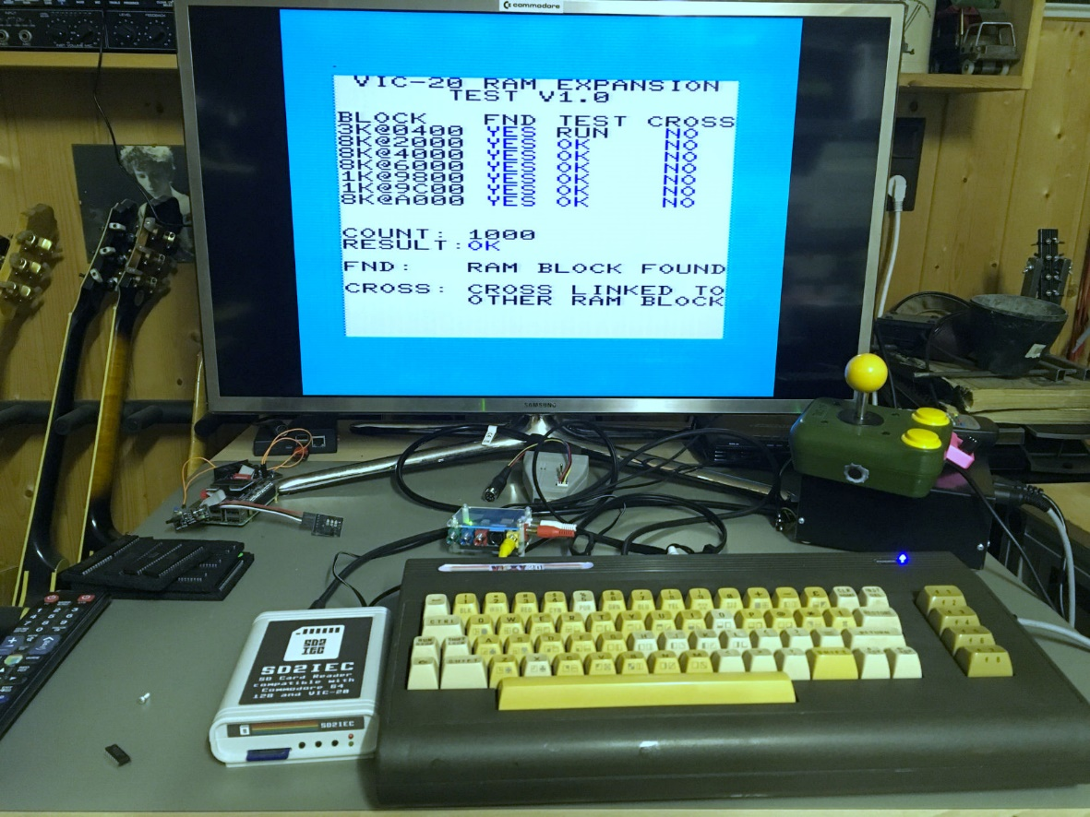

Figure 4: RAM Expansion Test running from EPROM

The version v1.0 of the RAM Test Software is capable of testing the RAM blocks attached to and . This software tests every bit in a RAM block for LOW and for HIGH. Also address line conflicts and a cross talk to other RAM blocks are detected.

EPROM configuration:

|  |  |  |  |  |  |  |  |
| --- | --- | --- | --- | --- | --- | --- | --- |
| SW3-8  CS1=CS2 | SW3-7  BLK3 | SW3-6  BLK1 | SW3-5  BLK5 | SW3-4  BLK2 | SW3-3 A15 | SW3-2  A14 | SW3-1  A13 |
| off | off | off | on | off | on | off | on |

RAM configuration

|  |  |  |  |  |  |  |  |
| --- | --- | --- | --- | --- | --- | --- | --- |
| SW2-8 | SW2-7 | SW2-6 | SW2-5 | SW2-4 | SW2-3 | SW2-2 | SW2-1 |
| off | on | on | off | on | on | on | on |

In the first pass, the RAM Test was running from the on-board EPROM IC1, configured to $A000 with BLK5). The test was running several thousand times without reporting any problems.

To test the 7th RAM bank configured at $A000, the EPROM was removed and the RAM @$A000 was activated. This test configuration did not report any problems, either.

|  |  |  |  |  |  |  |  |
| --- | --- | --- | --- | --- | --- | --- | --- |
| SW2-8 | SW2-7 | SW2-6 | SW2-5 | SW2-4 | SW2-3 | SW2-2 | SW2-1 |
| off | on | on | on | on | on | on | on |

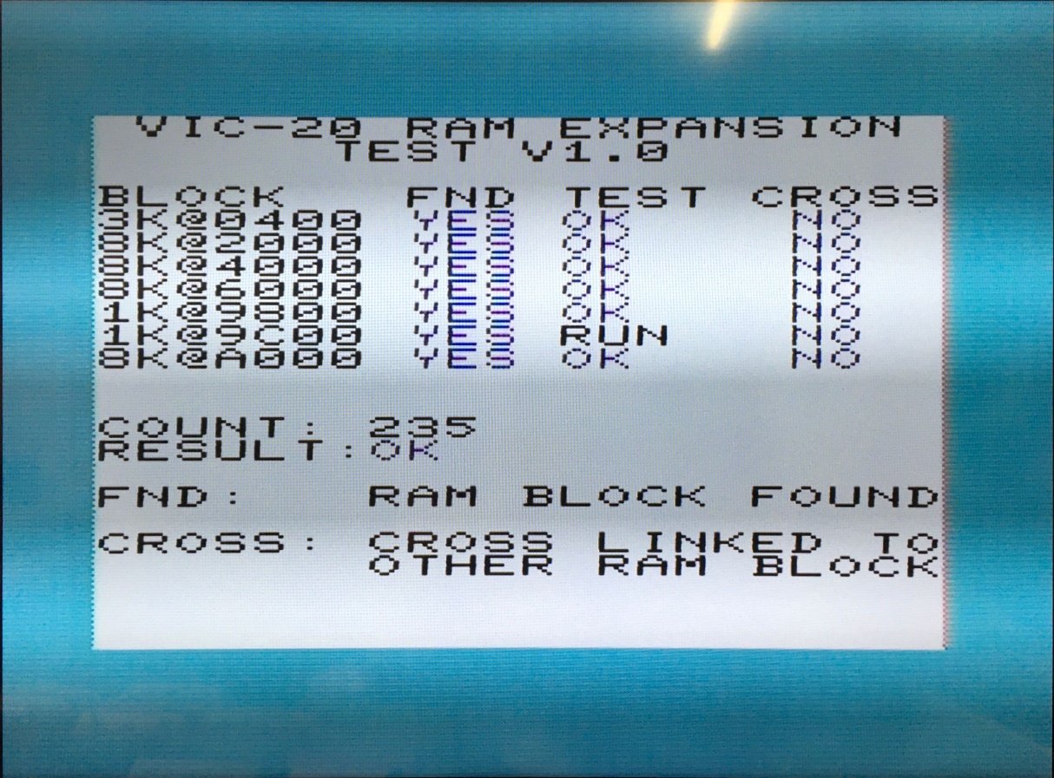

Figure 5: RAM Expansion Test running from a disk image

The game DOOM for VIC-20 requires 35k of RAM. It was played with all RAM activated and the EPROM deactivated.

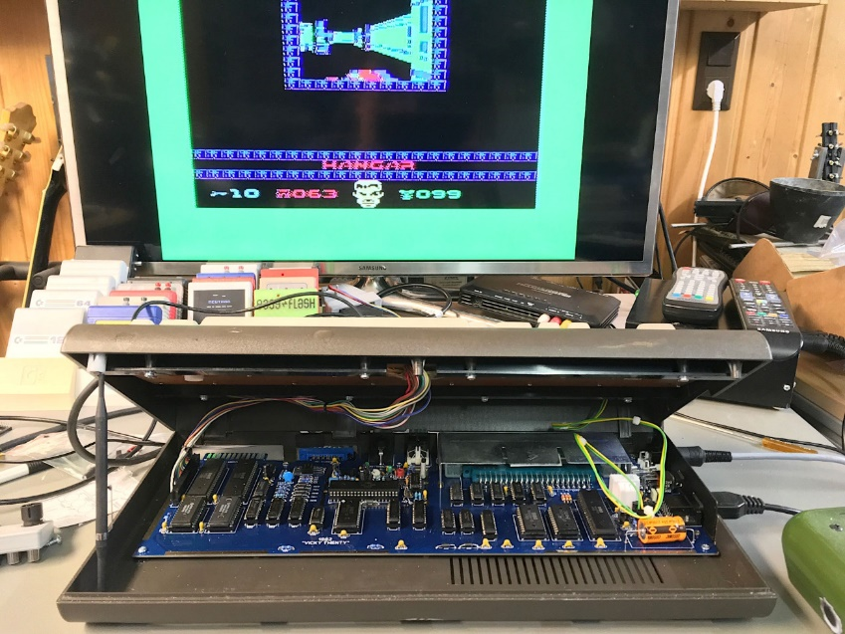

Figure 6: DOOM running on the VIC-20 with the Hyper Expander configured to maximum RAM

* **RAM function verified**

## Installation in cartridge cases

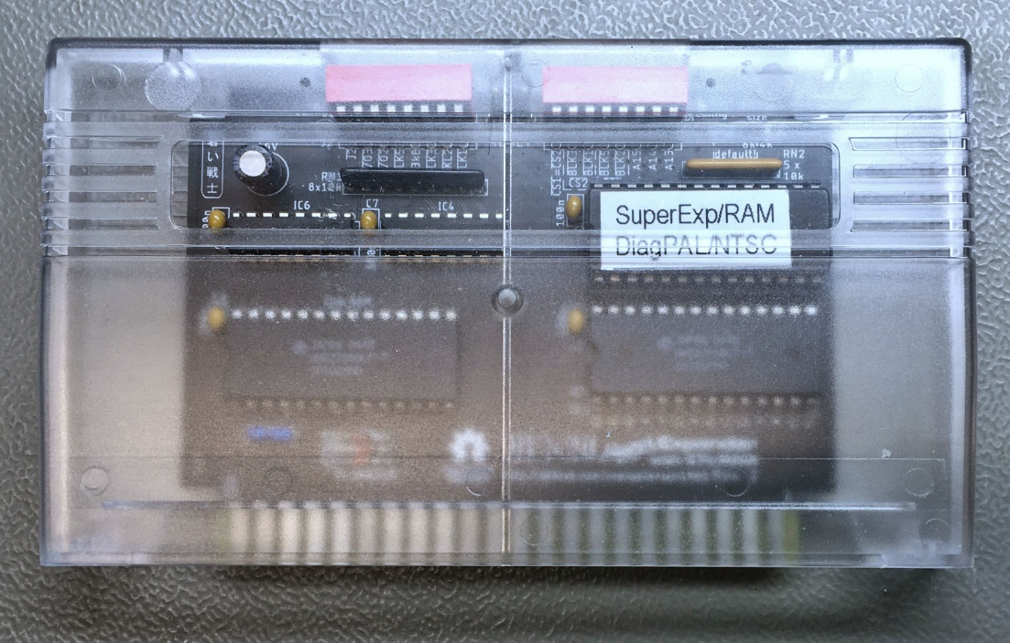

Figure 7: Installation in a tfw8bit case

The **tfw8bit.com VIC-20 cartridge case** fits after removing the support structures for the short PCBs.

In case the RESET switch is desired, the cases require a modification (5mm hole in the back)

* **Dimensions verified**

# Conclusion

**The Hyper Expander Rev. 2 is fully functional**